 |  | Newsletter | 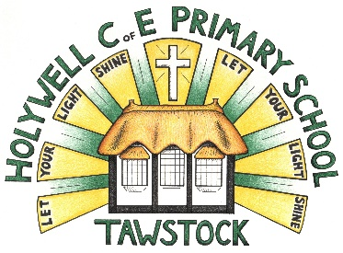  LET YOUR LIGHT SHINE  www.primaryschoolsbarnstaple.co.uk  holywell@ventrus.org.uk

1st March 2024
Holywell is a NO NUT Zone.

Message from Mrs. Lowrey
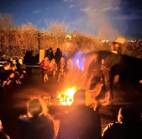
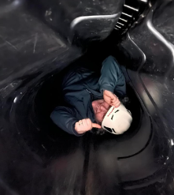
What a jam-packed week it has been at school! On Monday, we wished our Year 3 and 4 children off on an exciting adventure for the Skern Lodge residential. Mrs Bellew and Mr Day informed me that the trip was a huge success, with children showing excellent behaviours and great Holywell determination. The photos look amazing, children and I am exceptionally proud of the way you have thrown yourselves into these challenges. I did the disco was brilliant fun too! What excellent ambassadors for our school. I must also mention the small group who remained at school, who were also incredible this week and showed huge independence in their project learning – very well done!

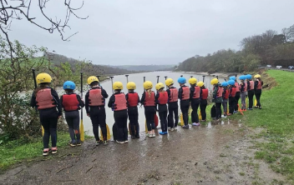
On Wednesday, we also took a group of Year5/6 girls to the football final at KIngsley, which you can read about in School news. It is certainly a week to be very proud of the manner in which the children have represented our school. Likewise, today, Callan and Willow have both attended the rising stars basketball at Pilton school. We are very proud of all of you, well done children! A huge thank you to the PTA also, who have funded the transport for these local events and are enabling our children to attend.

World Book Day – we are organizing lots of fun, reading activities in school and would like to invite all children to send in their “Extreme Reading Challenge” pictures! If you would like to take part, take a photo of your child in a place or doing something more extreme while they are reading! You may wish to do this in an unusual place (please be safe!) or in an unusual pose (gymnastics etc). Please post or photo on your class teams page or email your entry to the school. Prizes will be given to the top 3 entries and they need to be posted by the end of the school day on Wednesday 6th March.

Site update – this week, we have been visited by architects, who have used specialist machinery to complete a full internal site analysis before it is cleared. We have also received notification from North Devon planning that planning permission will not need to be sought due to the internal rebuild nature of the works. The next step would be to begin to clear the classroom and playground. Also, Mr Coles has been very busy getting quotes for repair work to windows. As soon as a date is set for the site to be cleared, I will let all parents know.

Thank you all for a busy, but super week!
Best wishes, Mrs Lowrey

School News

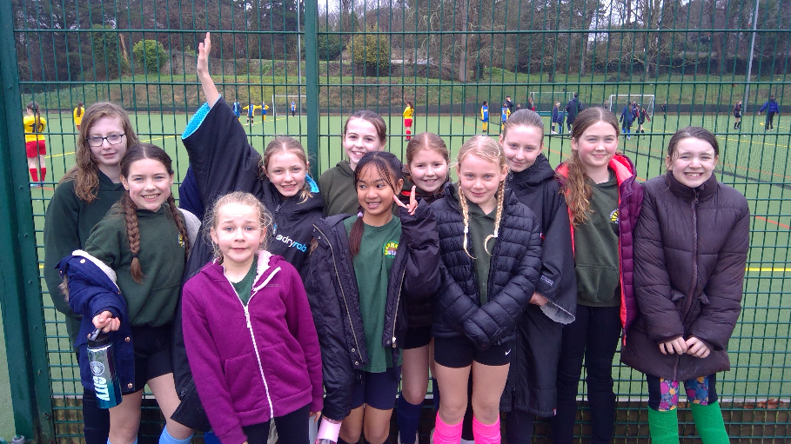

On Wednesday the year 5/6 girls took part in the North Devon U11 Girls Football Final at Kingsley.
They were one of 14 teams to qualify for the event. After some early nerves the girls grew in confidence with each game and were unlucky to not reach the knockout rounds on a single goal difference. The weather was not that kind to them, but they did have a visit from Mrs Hammond for a quick catch-up between matches.
Well done girls, you played your socks off and did yourselves and the school proud.

School Contact

In school, it is noticeable that some seasonal bugs are around at the moment and I can see that the children are tired. If your child is not well, please do phone the school and leave a message or feel free to email the school on holywell@ventrus.org.uk.

You can contact the school by phoning 01271 345908. If the phone is not answered, can you please leave a message on the answerphone. These messages will be responded to as soon as possible.

Links you may find useful.
HANDi Paediatric app: advice for common childhood conditions - One Devon

Diary Dates
Wednesday March 6th – Year 5 dance festival @Park School – transport to be provided (Year 5s, please wear PE kit on this day)
Thursday March 7th - World Book Day - Dress up and book based activities – after school Book and Bake sale!
Friday 8th March - Year 3 & 4 Girls Football Festival @ Tarka
Wednesday 20th March - Dental Survey – Children Aged Year 5 - Please return the forms sent home
Thursday 21st March – Holywell and Roundswell cross country festival
Tuesday 26th March - Barnstaple boys football finals @ Tarka
Wednesday 29th March – Easter Church service – 2-3pm – please collect from the church
Easter Disco – date TBC

Term Dates
Last day of the Spring Term – Thursday 28th March 2024
First day of the Summer Term – Monday 15th April 2024

School Uniform
https://schoolthreads.org/collections/holywell-c-of-e

PE T-shirts will still be available to purchase from school.

Ventrus Job Vacancies
https://ventrus.current-vacancies.com/v?id=VENTRUSMUL&t=Ventrus-Careers
Including vacancies at local schools.

Free School Meals
Check if your child can get free school meals and additional funding support.
All children in reception, year 1 and year 2 at state schools in England automatically get free school meals. However, parents and guardians are encouraged to apply for free school meals when they enrol their child in school, as this can help their child’s school to attract additional ‘pupil premium‘ funding to support learning.
From year 3 onwards, children whose parents are getting any of the following are entitled to free school meals:
- Universal Credit (provided you have an annual net earned income of no more than £7,400, as assessed by earnings from up to three of your most recent assessment periods).
- Income Support (IS).
- Income-based Jobseekers Allowance (IBJSA).
- Income-related Employment and Support Allowance (IRESA).
- The guaranteed element of State Pension Credit.
- Support under Part VI of the Immigration and Asylum Act 1999.
- Child Tax Credit (provided you’re not also entitled to Working Tax Credit and have an annual gross income that does not exceed £16,190).
- Working Tax Credit run-on (the payment you get for a further 4 weeks after you stop qualifying for Working Tax Credit).

How to apply
Apply through the Devon Citizens Portal. This is the quickest and easiest way to apply and will result in you getting an instant decision. Alternatively, call the Education Helpline on 0345 155 1019.

School Transport
https://www.devon.gov.uk/educationandfamilies/school-information/school-and-college-transport/
School and college transport – Education and Families
School transport information, including free school transport.
www.devon.gov.uk

NEW Privacy Notices – November 2023
Important information
Ventrus main privacy notice can be found at https://ventrus.org.uk/our-people/privacy-notices/

Ventrus pupil privacy notice can be forum at https://ventrus.org.uk/wp-content/uploads/2022/11/Pupil-Privacy-Notice-2022-23-Academy-Ventrus-Nov-22.pdf

Community Events

