 |  | Newsletter | 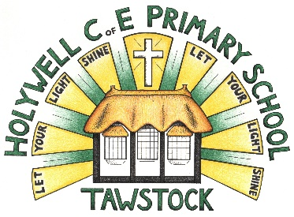  LET YOUR LIGHT SHINE  www.primaryschoolsbarnstaple.co.uk  holywell@ventrus.org.uk

9th February 2024
Holywell is a NO NUT Zone.

Message from Mrs. Lowrey

Today has been a very happy day at Holywell, which is very fitting before our half term break. As I stood and watched at lunchtime, all around me were children across two schools, laughing and playing together. We even watched a huge game of duck, duck, goose unfold, with 40 or so children playing happily together.
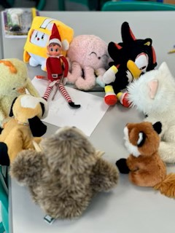
Not only that, but also, Mrs Bellew and Foxes class were celebrating their 75 pebbles with a “Teddy day”. It was a pleasure to have so many visitors – who were very well-behaved and wore seat belts on the bus! Until a cheeky elf crept in at lunchtime and wrote a note and gathered all of the teddies together…! Thomas, what a very cheeky elf you have – I wonder how he managed to do that at lunchtime?
Earlier in the week, I saw some fantastic science work from Foxes class and I know the Year 5/6 children received some of their first RSE classes, well done everyone! In Robins, the children have been completing their independent writing and I have seen some excellent examples of writing from Henry, Jack, Charlie and Violet. They have amazed us with the quantity that they are writing in their books – very well done!
For your information, there are some added dates in the section below, as well as fliers for coming events. Please do scroll through to see what is coming up. For your information, we are discussing further trips for summer term as well as residential to London next year. I will share further details as they become available.
To keep you updated on the progress of the Holywell site, I have been made aware that the site has now been seen twice and consideration has been given to enabling cranes and equipment onto the school. Since the visits, the contractors have now passed the scheduled works back to the insurers to approve. I understand that at this point, we are simply having to wait for this to be signed off, so do not yet have further news of a date, but I will share as soon as I hear.
Finally, please could I just offer a polite reminder regarding packed lunches and healthy options. I know many of you are more than aware, but please do make sure that your child’s packed lunch has a balanced range of foodstuffs for your child at lunch time. These should, of course, still be nut free. I know that this may seem obvious, however, at times it is easy to overlook hidden sugars.
That’s it for now, I do hope you all have a fantastic half term and I look forward to a little bit of spring weather next half term.
Best wishes, Mrs Lowrey
School News

Parking at Roundswell.
Brookside, Tews Lane and Claypit Road.
Firstly, can we please take this opportunity to thank all our parents who are respectful to the local residents when dropping off and collecting their children from Roundswell.
We appreciate that parking at Roundswell and at OV have caused new frustrations for our parents and make us all appreciate how fortunate we are at Holywell with the use of the village hall car park and that the school is not in a built-up residential area.

However, please can we ask that you do not park across people's drives or in their predesignated parking spaces at Brookside as this is not acceptable. Residents trying to leave are either having their journeys delayed and, in one case, a medical equipment delivery was delayed.

This message is also being sent out to Roundswell parents as we appreciate that this doesn't only apply to our parents.

School Contact
You can contact the school by phoning 01271 345908. If the phone is not answered, can you please leave a message on the answerphone. These messages will be responded to as soon as possible.

Links you may find useful.
HANDi Paediatric app: advice for common childhood conditions - One Devon

Diary Dates
Swimming Year R, 1 and 2 –6th and 20th February. Please collect your child from the Tarka Leisure Centre at 3pm. Siblings will be looked after at Roundswell until you arrive.
W/C- February 5th – Children’s mental health week
Tuesday 20th February – Devon Cricket engagement day with Martin Brice
Thursday 22nd Junior parkrun assembly (HW & RW children) in hall @ 1.15pm.
Wednesday 28th February - ND girls football finals @ Kingsley – selected children
February 26th – February 28th inclusive - Skern Lodge residential
1st March – Rising stars day 2 (selected children)
Thursday March 7th - World Book Day - Dress up and book based activities
Friday 8th March - Year 3 & 4 Girls Football Festival @ Tarka

Wednesday 20th March - Dental Survey – Children Aged Year 5 - Please return the forms sent home.
Thursday 21st March – Holywell and Roundswell cross country festival
Tuesday 26th March - Barnstaple boys football finals @ Tarka

Term Dates
Spring Half Term – Monday 12th February to Friday 13th February (inclusive).
Last day of the Spring Term – Thursday 28th March 2024
First day of the Summer Term – Monday 15th April 2024

School Uniform
https://schoolthreads.org/collections/holywell-c-of-e

PE T-shirts will still be available to purchase from school.

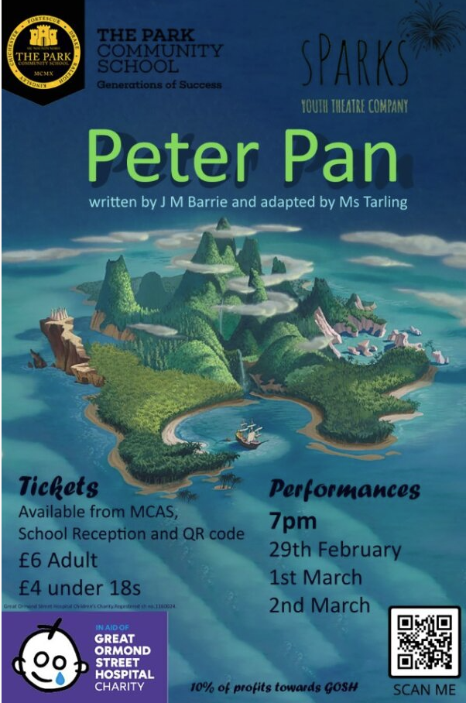

Ventrus Job Vacancies
https://ventrus.current-vacancies.com/v?id=VENTRUSMUL&t=Ventrus-Careers
Including vacancies at local schools.

Free School Meals
Check if your child can get free school meals and additional funding support.
All children in reception, year 1 and year 2 at state schools in England automatically get free school meals. However, parents and guardians are encouraged to apply for free school meals when they enrol their child in school, as this can help their child’s school to attract additional ‘pupil premium‘ funding to support learning.
From year 3 onwards, children whose parents are getting any of the following are entitled to free school meals:
- Universal Credit (provided you have an annual net earned income of no more than £7,400, as assessed by earnings from up to three of your most recent assessment periods).
- Income Support (IS).
- Income-based Jobseekers Allowance (IBJSA).
- Income-related Employment and Support Allowance (IRESA).
- The guaranteed element of State Pension Credit.
- Support under Part VI of the Immigration and Asylum Act 1999.
- Child Tax Credit (provided you’re not also entitled to Working Tax Credit and have an annual gross income that does not exceed £16,190).
- Working Tax Credit run-on (the payment you get for a further 4 weeks after you stop qualifying for Working Tax Credit).

How to apply
Apply through the Devon Citizens Portal. This is the quickest and easiest way to apply and will result in you getting an instant decision. Alternatively, call the Education Helpline on 0345 155 1019.

School Transport
https://www.devon.gov.uk/educationandfamilies/school-information/school-and-college-transport/
School and college transport – Education and Families
School transport information, including free school transport.
www.devon.gov.uk

NEW Privacy Notices – November 2023
Important information
Ventrus main privacy notice can be found at https://ventrus.org.uk/our-people/privacy-notices/

Ventrus pupil privacy notice can be forum at https://ventrus.org.uk/wp-content/uploads/2022/11/Pupil-Privacy-Notice-2022-23-Academy-Ventrus-Nov-22.pdf

Community Events
We are excited to share with you an initiative that is set to bring a burst of creativity and community spirit to Barnstaple – the 'Carnival!' event at Barnstaple Pannier Market

In collaboration with the Flourishing Barnstaple project, we are reaching out to extend an invitation for students, families, and teachers to be part of this vibrant celebration. Here's a glimpse of what's in store:

Event details:
- Dates: Tuesday, 13 February, to Saturday, 17 February (Half-term holidays)
- Location: Barnstaple Pannier Market

Highlights:
- Photography exhibition: Immerse yourselves in large-scale photographs capturing the essence of past carnivals in Barnstaple and around the world.
- Family Fun Day - Mardi Gras: Join us on Tuesday, 13 February, for a day filled with live music, face-painting, crafts, circus fun, and magic – a perfect opportunity for families to enjoy the joy of carnival traditions.

Free workshops:
- Throughout the week, there will be free workshops on drumming, dance, circus skills, and carnival crafts. A chance for individuals to explore their potential contributions to this year's carnival.

We believe that events like these play a crucial role in fostering community pride and creativity. We invite students to actively participate in the workshops and contribute their ideas to the organisation of this year's carnival.

Please note that workshop participation is on a first-come-first-served basis.

This initiative is made possible thanks to the generous support from the Cultural Development Fund, administered by Arts Council England, on behalf of the Department for Digital, Culture, Media, and Sport.

