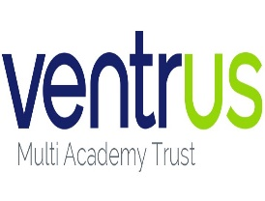 |  | Newsletter | 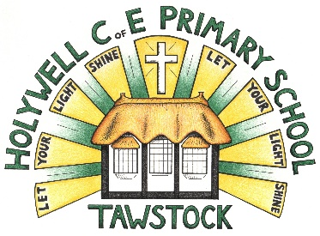  LET YOUR LIGHT SHINE  www.primaryschoolsbarnstaple.co.uk  holywell@ventrus.org.uk

10th November 2023
Holywell is a NO NUT Zone.

Message from Mrs. Lowrey

Please do scroll through for important dates and information regarding Christmas activities.

The Dalai Lama said: “Be kind whenever possible. It is always possible.”

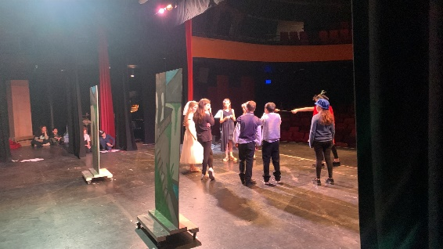
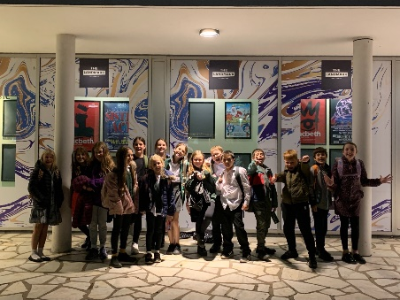
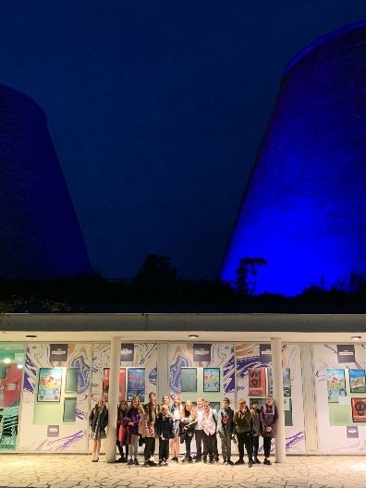
I saw this quote on an email I received today and it struck me how much this has been exemplified by our children and community this week. Part of our school values are about kindness and the group of children who attended the Shakespeare Schools Festival on Wednesday were an excellent example of how we can work together to achieve something special. I know that I was incredibly proud, not only of how the children supported each other through the rehearsals and the performance, but through the number of times that I was stopped by members of the public commending our children on their excellent behaviour and polite and respectful conduct. Children, you were incredible! It takes great courage to stand on stage in front of a big crowd and this is a fantastic achievement. Well done!
“I liked the Shakespeare play because it was a great experience for me and to face my fear talking in front of loads of people. It was very fun. I thank all of the parents for coming and thanks for Mrs Lowrey for teaching us the play.” – Issac

“I really enjoyed the Shakespeare play because I really like acting and I would like to be an actor and this was my first step. I’m thankful for Mrs Lowrey for directing the play and all of my friends for supporting everyone in it.” – Emily

“It was different to the normal plays that we do at school on our stage. It was a marvellous experience. Waiting in the wings is exhilarating! Saying your lines on stage is a joy because you get to show your family all of your hard work. Thank you Mrs Lowrey for entering and directing the performance.” - Mia

I asked the children to write down what they enjoyed and am so pleased with their thoughts that I decided to share them with you. (I promise that I didn’t ask them to thank me! That being said, children, you were all so polite, well-mannered and an absolute joy to take to the theatre. You should be so proud of yourselves and it is an absolute pleasure to help! Thank you for the kind words, children.)

Car park

As we are now using the hall for breakfast and after school clubs, it is becoming increasingly important to highlight the importance of arriving carefully in cars. Please could I ask that we leave the section with the yellow chevrons clear to enable the children a space to safely walk through and please do look out for children. I completely understand that pick up and drop off times can be a stressful time of day, but this will become increasingly important as the mornings and evenings are darker than before. Thank you!

Christmas dinner

It is after much conversation with the teaching staff and some parents that I have made the difficult decision to host Christmas dinner just for the children this year. This has not been an easy decision as I understand that historically, we have been able to invite our community in. However, the reasons are many, with cost of living creating additional family stressors, for Christmas dinner, I do not wish to add unnecessary issues for some and likewise, I know that this style of event can also create tensions for some who are unable to attend and do not wish to disappoint their child. The idea for the Christmas dinner is to allow the children a school based event and we will use this as an opportunity for the children to have a celebratory Christmas dinner with their class and with their teachers. I know this may disappoint some families and others may be appreciative, but I hope that everyone will understand the need to make a balanced decision in the current climate. I am hoping that the inclusion of two Christmas plays (with mince pies!) will provide our community with the opportunity to feel festive in school.

Christmas plays

I am excited to share that this year we will be putting on a performance of “Don’t be afraid!” a modern nativity for everyone to be a part of! We are currently putting together the speaking parts across all three classes and beginning to learn the songs. I am sure that you will all know them by December!

I can now confirm with you that we will be doing performances on the following dates:

Wednesday 6th December – 2pm
Thursday 7th December – 9.30am

We will set up a MS forms link for you to reserve seats for each show and email this to you next week. We will allow 2 seats per child as priority seats, but obviously understand that in some cases, 2 seats per parent will be needed. We will also enable additional seats for extended family if this is needed – please do ask on the form. This is only to help us to make sure that we can safely provide the space in the hall.

NSPCC assemblies

Next week we will be delivering assemblies provided by the NSPCC to discuss issues surrounding speaking out against abuse. These are age-appropriate assemblies that are approved and designed to support all children to understand about keeping themselves safe. We will be doing follow up workshops later in the term and the children will be asked to feedback later in the term. I will be sending you a letter today which outlines the programme to you as parents.

Tempest Photos (additional date)

Thank you for your understanding in regard to any confusion caused through the organization of tempest photographs. I understand the date was penciled in last year, but that the date was never confirmed with the school. We have now received the date for anyone who missed the photos this week (mainly those at the Shakespeare) and I can also confirm that we have a date in the calendar for this time next year, November 2024. Apologies for any disruption caused.

I do hope that you have a wonderful weekend,

Best wishes,

Mrs Lowrey

School News

Admissions policy for 2025-26: Annual Consultation
Along with all other schools and academies in Devon, we are consulting on an admission policy for 2025-26. The Local Authority is also consulting on its admission arrangements. You are invited to look at the proposals and have your say. Our proposed policy is on our admission page weblink and you can see all policies at http://devon.cc/schoolpolicy . Further information is here: www.devon.gov.uk/admissionarrangements

The consultation runs until 12 January 2024. Policies will be determined on 31st January 2024 and published in the same places by 15 March 2024.

Year 3 & 4 Swimming
Thank you to those parents who have paid for the Swimming sessions this term. We have arranged on ParentPay that this can be paid in two instalments so if you have not yet paid can we please ask that you do this as soon as possible.

Admissions to Reception Year for September 2024
Further details can be found at Apply for a reception or year 3 place at a primary school (devon.gov.uk) The Application window for the September 2024 Intake will open on 15th November 2023.
Useful Links and Information:
Here are some useful links that may assist you with your query
In Year Admission Information - Apply for an in-year place - Education and Families (devon.gov.uk)
School Catchment Area Checker - School designated (catchment) areas - Education and Families (devon.gov.uk)
Admission Advice for international arrivals Admission advice for international arrivals - Education and Families (devon.gov.uk)
Guide to School Appeals School admission appeals Archives - Education and Families (devon.gov.uk)

Diary Dates
Parent Conference - Tuesday 14th November – please see Teams for sign up if you have not yet done so
Parent conference - Thursday 16th November
Tempest photos – Thursday 16th November PM (Those who were absent this week – Shakespeare)
Bikeability – Tuesday 21st and Wednesday 22nd November (years 5/6)
Rising stars sports – selected children – 28th November
Christmas Plays – Weds 6th December and Thursday 7th December
Christmas lunch and Christingle – Wednesday 13th December
Christmas Jumper Days – for a one-off donation of £2.00 per child for Save the Children charity – Friday 1st December, Friday 8th December and Friday 15th December.

Term Dates
End of Autumn Term – Friday 15th December

LET’S TALK
A series of free online sessions for parents and carers of young people aged 9 – 12.
https://eur02.safelinks.protection.outlook.com/?url=https%3A%2F%2Fwww.eventbrite.co.uk%2Fe%2Flets-talk-pre-teens-september-2023-tickets-680101400597%3Faff%3Doddtdtcreator&data=05%7C01%7CElaine.Palmer%40ventrus.org.uk%7C07cef0981f874fda0a8108dbab7b83de%7C668515dda7fb41788c34b3c52dd93f70%7C1%7C0%7C638292319191735230%7CUnknown%7CTWFpbGZsb3d8eyJWIjoiMC4wLjAwMDAiLCJQIjoiV2luMzIiLCJBTiI6Ik1haWwiLCJXVCI6Mn0%3D%7C3000%7C%7C%7C&sdata=l7IDTWBJ9C6bdvG07OH5SWQyNG2Bo2X1sqarjZEJFC0%3D&reserved=0

School Uniform
We are in the process of moving our school uniforms sales from school to Daw’s at Daw’s Clothing Company Ltd, Unit 2 Affinity Devon, (Atlantic Village) Clovelly Road, Bideford.
As we sell out of items they are taking them on and can be purchased on-line at:
https://schoolthreads.org/collections/holywell-c-of-e

PE T-shirts will still be available to purchase from school.

Ventrus Job Vacancies
https://ventrus.current-vacancies.com/v?id=VENTRUSMUL&t=Ventrus-Careers
Including vacancies at local schools.

Free School Meals
Check if your child can get free school meals and additional funding support
All children in reception, year 1 and year 2 at state schools in England automatically get free school meals. However, parents and guardians are encouraged to apply for free school meals when they enrol their child in school, as this can help their child’s school to attract additional ‘pupil premium‘ funding to support learning.
From year 3 onwards, children whose parents are getting any of the following are entitled to free school meals:
- Universal Credit (provided you have an annual net earned income of no more than £7,400, as assessed by earnings from up to three of your most recent assessment periods).
- Income Support (IS).
- Income-based Jobseekers Allowance (IBJSA).
- Income-related Employment and Support Allowance (IRESA).
- The guaranteed element of State Pension Credit.
- Support under Part VI of the Immigration and Asylum Act 1999.
- Child Tax Credit (provided you’re not also entitled to Working Tax Credit and have an annual gross income that does not exceed £16,190).
- Working Tax Credit run-on (the payment you get for a further 4 weeks after you stop qualifying for Working Tax Credit).

How to apply
Apply through the Devon Citizens Portal. This is the quickest and easiest way to apply and will result in you getting an instant decision. Alternatively, call the Education Helpline on 0345 155 1019.

https://eur02.safelinks.protection.outlook.com/?url=https%3A%2F%2Fwww.devon.gov.uk%2Feducationandfamilies%2Fschool-information%2Fschool-meals%2F&data=05%7C01%7CElaine.Palmer%40ventrus.org.uk%7Cecb748a1694549cf9d0d08dbab7b6f66%7C668515dda7fb41788c34b3c52dd93f70%7C1%7C0%7C638292318849767515%7CUnknown%7CTWFpbGZsb3d8eyJWIjoiMC4wLjAwMDAiLCJQIjoiV2luMzIiLCJBTiI6Ik1haWwiLCJXVCI6Mn0%3D%7C3000%7C%7C%7C&sdata=MPmLE78rMu0DP1khLjP7BHOHwf5yQWoQEPlCI7ngJO4%3D&reserved=0

School Transport
https://www.devon.gov.uk/educationandfamilies/school-information/school-and-college-transport/
School and college transport – Education and Families
School transport information, including free school transport
www.devon.gov.uk

NEW Privacy Notices – November 2023
Important information
Ventrus main privacy notice can be found at https://ventrus.org.uk/our-people/privacy-notices/

Ventrus pupil privacy notice can be forum at https://ventrus.org.uk/wp-content/uploads/2022/11/Pupil-Privacy-Notice-2022-23-Academy-Ventrus-Nov-22.pdf

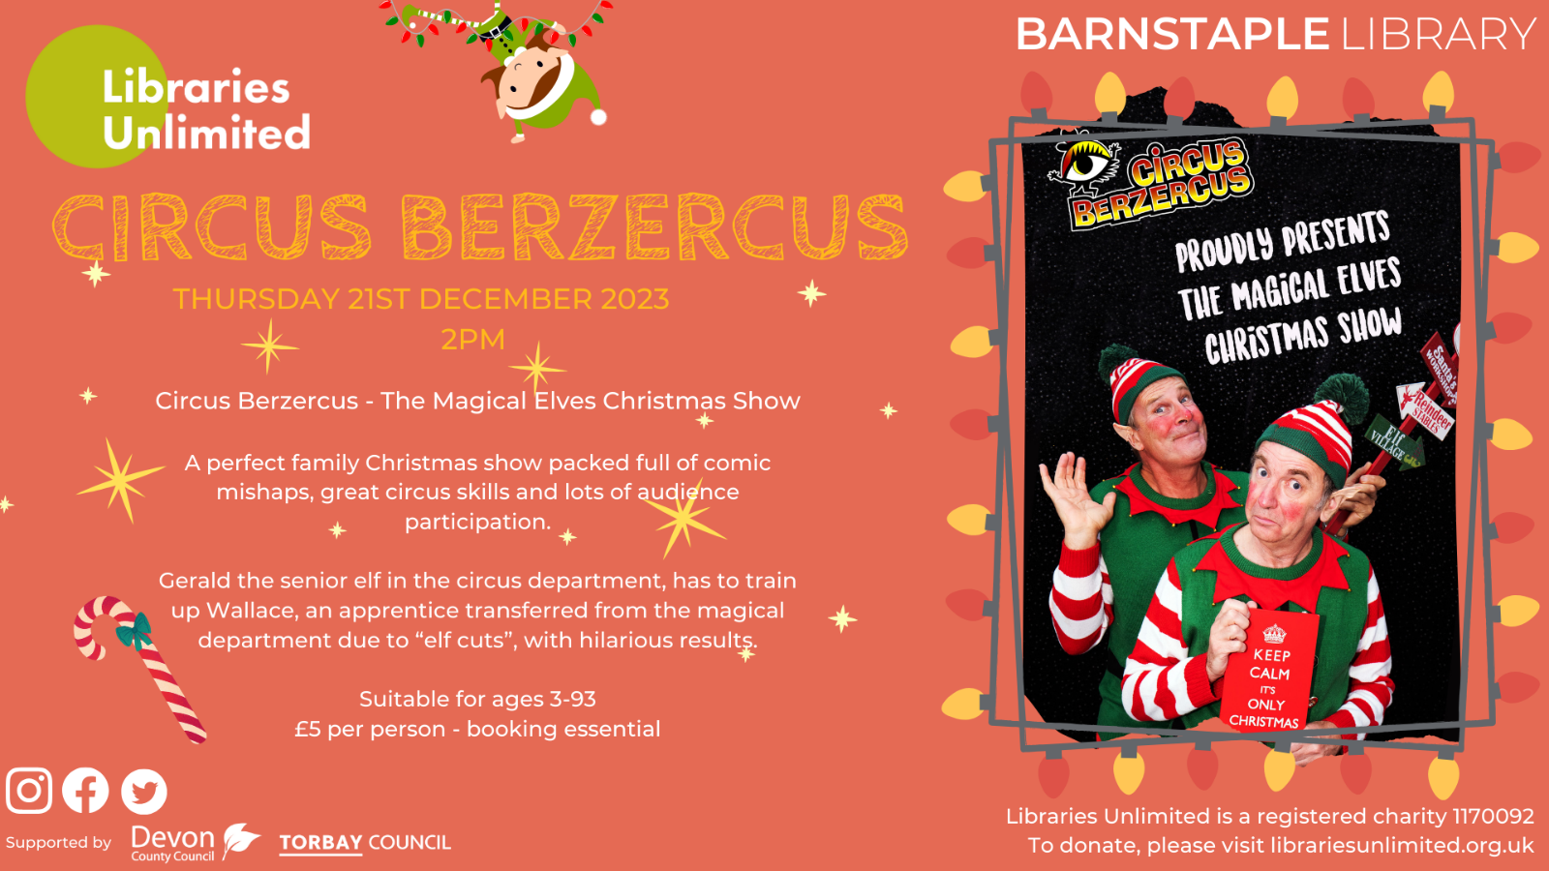

Community Information

Barnstaple is set to become the celestial centrepiece of North Devon this December, as "Museum of the Moon", a captivating artwork by UK artist Luke Jerram, lands in the newly regenerated Barnstaple Pannier Market.
Get ready to visit the market in a whole new light and immerse yourself in something truly extraordinary. This stunning artwork has been presented in over 300 different ways, across 30 different countries, and has captivated the hearts of more than 20 million people worldwide.
Don't miss your chance to be a part of this global sensation right here in Barnstaple! Secure your FREE place now to avoid disappointment – https://www.seetickets.com/tour/museum-of-the-moon
We understand that some visitors may prefer a quieter, calmer setting, which is why we have times available with enhanced lighting and lower music levels. Plus, we're limiting the number of available places to ensure everyone can fully immerse themselves in this experience. Book your experience now: https://www.seetickets.com/tour/museum-of-the-moon-relaxed-viewing
As well as the viewing of the moon, we have some additional activities running alongside, one being:
Family Silent Disco beside the Moon
North Devon Silent Disco and Silent Disco World bring you a unique Family Silent Disco like no other. The UKs Best Silent Disco Djs playing the most uplifting party tunes on the planet with Barnstaple’s historic Pannier Market lit up like you’ve never seen it before.
What better way to start the New Year than with a full family party in the shadow of Luke Jerram’s MOON!
Choose from three Channels of anthems, classics and sing-along bangers served up by the UKs top silent disco DJs.
80’s 90’s Naughties and NOW, Pop, Commercial, House, Garage, Rock, Hip hip, DnB
Buy your tickets now: https://www.seetickets.com/tour/family-disco-beside-the-moon
Venue: Barnstaple Pannier Market
Date: Monday 1 January 2024
Times: 2:30PM - 5PM
We hope you will join us.

